AI-BASED FUEL-EFFICIENT ROUTE OPTIMIZATION SYSTEM USING INTERNET OF VEHICLES (IOV)
A Project Report Submitted
In partial fulfilment of the requirements for the award of the degree of
Bachelor of Technology
In
Computer Science and Engineering
Submitted By:
Manali Ghosh (17600122054)
Ananya Pan (17600122045)
Dipankar Manna (17600122033)
Ankit Pramanick (17600122063)
Under the guidance of
Rakhi Chakraborty, Assistant Professor, Dept. of CSE


Department of Computer Science and Engineering
Hooghly Engineering & Technology College, Hooghly

Affiliated to
Maulana Abul Kalam Azad University of Technology,
West Bengal

2025-26


HOOGHLY ENGINEERING & TECHNOLOGY COLLEGE
Vivekananda Road, Pipulpati, P.O. & Dist-Hooghly (WB), Pin-712103
(Affiliated to Maulana Abul Kalam Azad University of Technology)

CERTIFICATE

This is to certify that the project entitled “Project Title: AI-Based Fuel Efficient Route Optimization System using Internet of Vehicles (IoV)” has been submitted to the Department of Computer Science and Engineering, Hooghly Engineering & Technology College, Hooghly in partial fulfilment for the award of Bachelor of Technology in Computer Science and Engineering by the following 4th Year 7th Semester students under the supervision of Rakhi Chakraborty, Assistant Professor, CSE Department, during a period from July, 2025 to December, 2025.
Their performances were found to be satisfactory.

Student Name (University Roll No.)
- Manali Ghosh (17600122054)
- Ananya Pan (17600122045)
- Dipankar Manna (17600122033)
- Ankit Pramanick (17600122063)

______________________ ________________________
Name of the Project Guide Dr. Sumanta Daw
Department of CSE HOD, Department of CSE

ACKNOWLEDGEMENT

It gives us immense pleasure to announce the partial completion of our project on “AI-Based Fuel-Efficient Route Optimization System” and we are pleased to acknowledge our indebtedness to all the persons who directly or indirectly contributed in the development of this work and who influenced our thinking, behaviour and acts during the course of study.
We are thankful to our respected departmental HOD Dr. Sumanta Daw and Coordinator Mr. Dibyendu Samanta who granted all the facilities of the college to us for the fulfilment of the project.
We are thankful and express our sincere gratitude to our project guide Ms. Rakhi Chakraborty who gave her valuable time to us for the sake of our project. She helped us each and every aspect of our project both academically and mentally.
Finally, the team expressed their gratitude to our respected Principal sir Prof. (Dr.) Bhabani Prasanna Pattanaik without his support our project would not have seen the light of success.
Student Name (with Roll No.) Signature
- Manali Ghosh (17600122054) ….……………………………….
- Ananya Pan (17600122045) ……………..…………………….
- Dipankar Manna (17600122033) ……………………………………
- Ankit Pramanick (17600122063) ……………………………………

4th Year, 7th Semester
Department of Computer Science and Engineering
Hooghly Engineering & Technology College
Academic Year: 2025-26

ABSTRACT

Fuel consumption has become a serious concern today because of rising fuel prices, traffic congestion, and increasing pollution. Most navigation apps only focus on finding the shortest or fastest route, but they do not consider important real-world factors like driving behaviour, traffic patterns, road slope, or vehicle performance. As a result, people often end up using more fuel than necessary.
In this project, AI-Based Fuel-Efficient Route Optimization System, we are working on building an intelligent model that predicts fuel usage more accurately using machine learning. The system uses vehicle behaviour patterns from datasets like the Extended Vehicle Energy Dataset (eVED), combines them with elevation information from digital elevation maps, and also considers traffic conditions. By learning how speed, acceleration, slope, and engine behaviour affect fuel usage, the model can estimate fuel consumption for different routes.
Using OpenStreetMap (OSM), the system generates multiple possible routes and calculates the predicted fuel needed for each one. Finally, it recommends the route that would consume the least amount of fuel while keeping the travel time reasonable.
With all these combined factors, the proposed system has the potential to reduce fuel usage by 10–18%, making travel more economical, eco-friendly, and personalised for different driving styles.

INDEX

SL NO. | DESCRIPTION | PAGE
I. | ABSTRACT | IV
 | INTRODUCTION | 1
 | REVIEW OF LITERATURE | 2
 | PROPOSED WORK | 3
 | PROJECT MODULES & FEATURES | 4
 | PLATFORM & TECHNOLOGY | 5
 | TECHNICAL DETAILS | 6
 | APPLICATION | 7
 | FUTURE SCOPE | 8
 | CONCLUSION | 9
 | REFFERENCES | 10

INTRODUCTION
Overview
Fuel efficiency and route planning have become extremely important today due to increasing fuel costs and heavy traffic. Traditional routing apps mainly focus on saving time or distance, but they completely ignore how much fuel a route might consume. This project aims to solve that gap by designing an AI-based system that recommends routes based not just on distance or time but on actual predicted fuel usage.
Problem Identification
Current navigation systems mostly consider:
- shortest path
- fastest route
- live traffic
But they DO NOT consider:
- driving behaviour
- elevation & slope of roads
- engine load and throttle usage
- fuel consumption per road segment
This means the “fastest” route is often not the most fuel-efficient one.
Aim of the Project
To build an AI-powered system that predicts the fuel consumption for each possible route and recommends the most fuel-efficient one by considering driving behaviour, road elevation, and traffic.
Objectives
- Train ML models for accurate fuel consumption prediction
- Add elevation and slope information to the fuel model
- Generate multiple route options using OSM
- Compare predicted fuel usage across different routes
- Recommend the best fuel-saving route
- Provide insights based on driver behaviour
Significance
The system can help users:
- save fuel and money
- reduce CO₂ emissions
- improve vehicle performance
REVIEW OF LITERATURE

Traditional route planning systems primarily rely on shortest-path and fastest-route algorithms such as Dijkstra’s and A*, which optimize travel time or distance but do not consider fuel usage. As a result, these systems often recommend routes that may be quick but not fuel-efficient. To improve this, researchers introduced the concept of eco-routing, where the goal is to minimize energy consumption rather than travel duration. However, early eco-routing models used simplified assumptions such as constant speed or average acceleration, which failed to capture the complexity of real driving conditions.
Later studies recognized that fuel consumption depends strongly on multiple dynamic factors, including speed, acceleration, vehicle load, driver behaviour, road gradient, and traffic conditions. Several works attempted to model fuel usage using basic GPS data or vehicle specification datasets like the EPA Fuel Economy dataset. While useful, these datasets lacked detailed sensor information and real-world variability, limiting the accuracy of fuel prediction models.
More advanced approaches used machine learning to predict fuel consumption using parameters such as speed, RPM, throttle position, and acceleration patterns. Although these models performed better, many of them did not integrate map features such as slope, elevation, or route geometry. Studies also highlighted that road elevation has a significant impact on fuel consumption, especially in hilly terrain, making elevation-aware routing essential.
Recent research began incorporating traffic data and driver behaviour profiling, showing that aggressive acceleration, congestion, and frequent stops greatly increase fuel usage. However, most existing works focus on only one aspect either behaviour, or terrain, or traffic resulting in incomplete optimization.
The release of comprehensive datasets like the Extended Vehicle Energy Dataset (eVED) provided a breakthrough. eVED includes GPS trajectories, speed, throttle, fuel rate, and elevation, enabling more accurate fuel prediction through ML models like Random Forest and XGBoost. Still, most studies using eVED focus only on fuel prediction and do not extend this knowledge into full route optimization.
Overall, the existing literature shows a clear gap: there is no unified system that simultaneously considers driving behaviour, elevation, traffic, and vehicle sensor data to calculate fuel consumption for complete routes. This project aims to fill that gap by combining machine learning based fuel prediction with map-based route analysis, creating a more practical and accurate fuel-efficient route recommendation system.

PROPOSED WORK

The proposed work focuses on developing an AI-based system that can accurately predict fuel consumption and recommend the most fuel-efficient route by combining real-world driving behaviour, terrain information, and traffic conditions. The system is designed to overcome the limitations of traditional navigation applications that only consider distance or time.
To achieve this, the project uses the Extended Vehicle Energy Dataset (eVED) as the primary data source. This dataset contains detailed vehicle sensor information such as speed, throttle position, acceleration, RPM, GPS coordinates, and fuel rate. These parameters help the model understand how different driving patterns influence fuel usage. The dataset is pre-processed to clean missing values, extract features, and prepare it for model training.
Next, the system incorporates elevation and slope data, which are essential because climbing uphill or driving on steep roads increases fuel consumption significantly. Elevation values are taken from digital elevation models, and slope is calculated for each road segment to improve prediction accuracy. Additionally, traffic information from APIs like Google Maps or TomTom can be integrated to estimate the effect of congestion and stop-and-go conditions.
A machine learning model is then trained to predict fuel consumption using features derived from driver behaviour, vehicle dynamics, and terrain. Models like Random Forest, Gradient Boosting, or XGBoost are used because they perform well with real-world, non-linear data.
Once the fuel prediction model is ready, the system generates multiple candidate routes between the source and destination using OpenStreetMap (OSM) and tools like OSMnx or OSRM. Each route is divided into smaller segments, and the trained model predicts fuel consumption for each segment. The segment-wise values are summed up to estimate the total fuel required for each route.
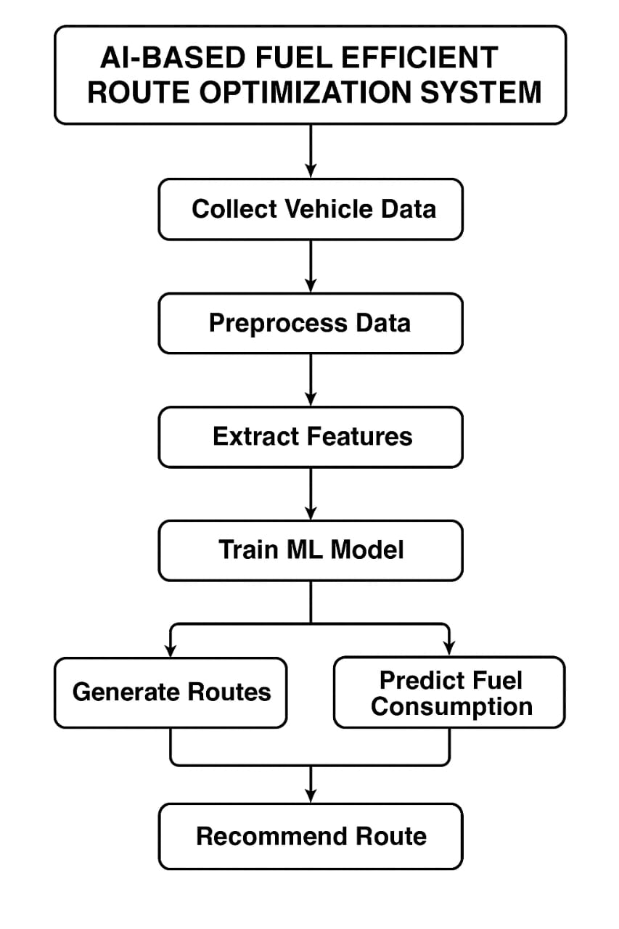
Finally, the system compares all candidate routes based on the predicted fuel consumption and recommends the route that requires the least amount of fuel while maintaining reasonable travel time. The novelty of the proposed work lies in integrating driver behaviour, elevation, traffic influence, and real vehicle sensor data into a single unified model for fuel-efficient route planning, which is not commonly addressed in existing systems.
This approach aims to provide users with practical, cost-saving, and environmentally conscious route recommendations, making travel more efficient and sustainable.

PROJECT MODULES & FEATURES
Modules
1. Dataset Preprocessing
The eVED dataset is cleaned, filtered, and converted into usable format. Missing values are handled, features are standardized, and irrelevant entries are removed.
2. Driver Behaviour Feature Extraction
Key behavioural factors such as speed, acceleration, RPM, throttle, and stop-and-go patterns are extracted to understand how driving style affects fuel usage.
3. Elevation & Slope Calculation
Elevation data is collected from digital elevation models, and slope for each road segment is calculated. This helps the system account for the effect of uphill/downhill roads on fuel consumption.
4. ML-Based Fuel Prediction
Machine learning models like Random Forest or XGBoost are trained using processed features. The model predicts fuel consumption for each segment based on behaviour, terrain, and vehicle parameters.
5. Route Generation
Using OpenStreetMap (OSM) and tools like OSMnx/OSRM, multiple possible routes are generated between the starting point and destination.
6. Traffic Integration
Traffic data from APIs is added to estimate congestion levels, as frequent stops and slow movement increase fuel usage.
7. Route Fuel Comparison
Fuel consumption is calculated for every route by summing predicted fuel values for all segments. Routes are compared based on their total estimated fuel usage.
8. Fuel-Efficient Route Recommendation
The system selects and recommends the route that consumes the least fuel while maintaining reasonable travel time.
Key Features
- Driver-aware fuel prediction using real behaviour patterns
- Terrain-based route scoring using elevation and slope
- Traffic-aware fuel estimation for real-world accuracy
- Accurate segment-wise fuel calculation for better route decisions
PLATFORM & TECHNOLOGY

Backend Technologies
1. Python
Python is used as the main programming language for implementing data preprocessing, model training, route calculations, and backend logic due to its simplicity and rich library support.
2. Scikit-learn
This library provides essential machine learning tools for preprocessing, feature extraction, and building baseline regression models for fuel prediction.
3. XGBoost
XGBoost is used to train high-performance gradient boosting models. Its accuracy and speed make it suitable for predicting fuel consumption based on complex driving and terrain features.
4. Flask
Flask acts as a lightweight web framework to build a simple user interface where users can input start and end points and view the recommended fuel-efficient route.
5. OSRM / OSMnx
These tools help extract road networks from OpenStreetMap and generate multiple route options. They also break routes into segments for fuel estimation.

APIs & Data Sources
1. Google Maps / TomTom Traffic API
These APIs provide real-time traffic data such as congestion and delay levels. This helps the system account for traffic-related fuel consumption.
2. NASA SRTM Elevation Dataset
The SRTM dataset supplies accurate elevation values for each coordinate. This allows calculation of slope, which is an important factor influencing uphill and downhill fuel usage.
3. eVED Vehicle Dataset
This dataset is used as the primary training source. It contains real driving data such as speed, RPM, throttle, acceleration, and fuel rate, enabling accurate ML-based fuel prediction.
4. OpenStreetMap (OSM) Road Data
OSM provides open-source road network information. It is used to generate possible routes and map them with elevation, traffic, and fuel predictions.

TECHNICAL DETAILS

1. Machine Learning Model Architecture
The system uses regression models such as Random Forest and XGBoost to predict fuel consumption. The model takes behaviour and terrain-based features as input and outputs the estimated fuel rate for each segment.
2. Data Preprocessing Pipeline
Raw eVED data is cleaned by handling missing values, removing noise, normalizing sensor readings, and mapping GPS points with elevation. The data is then split into training and testing sets.
3. Fuel Prediction Model
The model predicts fuel usage using features like speed, acceleration, throttle, RPM, slope, and elevation. It learns real driving patterns and identifies conditions where fuel consumption increases.
4. Route Generation Logic
Using OpenStreetMap with OSMnx/OSRM, multiple routes are generated and divided into smaller segments. Elevation and traffic data are added to each segment before calculating the predicted fuel requirement.
5. Evaluation Metrics
The performance of the ML model is evaluated using RMSE, MAE, and R² score to measure accuracy and ensure the predicted fuel values are close to real-world values.
6. Feature Engineering
Important features such as speed variation, acceleration, engine load, slope, elevation change, and stop-and-go behaviour are extracted to improve the prediction quality of the ML model.

APPLICATIONS

1. Navigation Apps
This system can be integrated into navigation platforms to recommend routes that minimize fuel usage instead of focusing only on distance or time.
2. Smart Transportation Systems
Smart city transport networks can use fuel-efficient routing to improve traffic flow and reduce overall energy consumption.
3. Fleet and Logistics Management
Delivery and logistics companies can optimize their vehicle routes to lower fuel expenses, reduce operational costs, and improve delivery efficiency.
4. Fuel Cost Optimisation
Individual users and organizations can save money by selecting routes that require the least amount of fuel based on real driving and terrain conditions.
5. Eco-Friendly Vehicle Routing
The system supports sustainable transportation by reducing unnecessary fuel burn, lowering emissions, and promoting greener travel choices.
6. Urban Mobility Planning
City planners can use the system’s insights to design more efficient road structures and traffic strategies that reduce fuel consumption at a larger scale.

FUTURE SCOPE

With the advancement of electric vehicles and intelligent transportation systems, there are several promising directions for future development in route optimization and smart mobility.
EV battery-aware route optimization can revolutionize navigation for electric vehicles by considering the vehicle’s current battery status along with distance, traffic conditions, and available charging stations. This ensures drivers can reach their destinations efficiently without worrying about running out of charge, while also optimizing energy consumption for eco-friendly travel.
Real-time sensor integration (OBD-II) allows navigation systems to access live vehicle data, including speed, engine performance, and fuel usage. By leveraging this information, routes can be dynamically adjusted to suit the vehicle’s current condition, helping reduce fuel consumption, enhance performance, and improve driver safety.
Pothole-aware routing is another area with significant potential. By using data from vehicle sensors and smartphones, navigation systems can detect road irregularities, such as potholes or damaged surfaces, and suggest smoother alternatives. This not only improves ride comfort but also minimizes vehicle wear and tear, making driving safer and more pleasant.
Reinforcement learning for adaptive eco-routing introduces machine learning techniques that continuously learn from traffic patterns, road conditions, and driver behaviour. Unlike traditional routing algorithms, these systems can adapt over time to suggest the most energy-efficient and fastest routes, helping reduce fuel consumption, lower emissions, and save travel time.
Finally, integration with public transport systems can create seamless multimodal travel experiences. Navigation systems can combine personal vehicle routes with bus, metro, or train schedules, suggesting hybrid options that reduce traffic congestion and improve overall urban mobility. This approach encourages sustainable travel while providing users with convenient and flexible routing options.
In conclusion, these developments point toward a future where navigation systems are not only more intelligent and adaptive but also eco-friendly, safe, and integrated with broader urban transport networks, offering a superior and sustainable travel experience for all users.

CONCLUSION

This project demonstrates how artificial intelligence can significantly enhance route planning by focusing on fuel efficiency rather than just distance or travel time. By combining machine learning with real-time and historical data on traffic, road elevation, and driver behaviour, the system is capable of recommending smarter, more efficient routes. Unlike traditional navigation applications, which primarily provide the shortest or fastest path, this AI-driven approach optimizes fuel consumption, reduces travel costs, and improves overall driving experience. Personalized route suggestions based on vehicle performance and driving patterns ensure that drivers can make informed decisions, enhancing both safety and efficiency on the road.
Moreover, the system has strong potential for future integration with electric vehicles, sensor-based data, and public transport networks, paving the way for more sustainable urban mobility. By reducing fuel usage and emissions, it contributes to environmentally friendly transportation while also offering economic benefits to users. Overall, this project highlights how intelligent route optimization can transform everyday travel into a smarter, greener, and more adaptive experience, demonstrating the practical value of AI in creating efficient and sustainable transportation systems.

REFERENCES
- B. Aslam, F. Khan, "Eco-Routing: Energy-Efficient Routing for Vehicles using Road and Traffic Information," IEEE Transactions on Intelligent Transportation Systems, 2019.
- S. S. A. Shah et al., "Machine Learning-Based Fuel Consumption Prediction Using Vehicle Telematics Data," Applied Energy, vol. 260, 2020.
- Boriboonsomsin and M. Barth, “Eco-Driving: Modeling and Control for Fuel Efficiency,” IEEE ITS, 2014.
- M. Barth and K. Boriboonsomsin, “Energy and Emissions Impact of Freeway Speed Limits and Lane Management Strategies,” Transportation Research Record, 2008.
- J. Kwon et al., “Impact of Road Grade on Vehicle Fuel Consumption,” Journal of Transportation Engineering, 2013.
- L. Sun et al., "Predicting Vehicle Energy Consumption Using Machine Learning Incorporating Road Grade and Driver Behaviour," Energy, 2021.

-----THANK YOU-----

